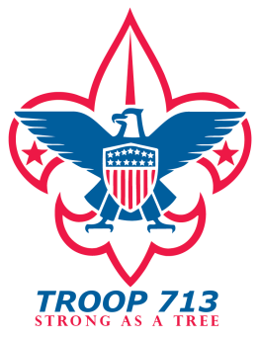
SHORT TERM CAMP
PATROL DUTY ROSTER

PATROL: DATE:

 | FRIDAY NIGHT | SATURDAY BREAKFAST |  | SATURDAY LUNCH |  | SATURDAY DINNER | SUNDAY BREAKFAST
COOK
ASSISTANT COOK
WATER
WASH DISHES
MEAL CLEANUP
FIRE BUCKET
SITE CLEANUP |  |  |  |  |  |  | ALL
PATROL
QUARTERMASTER
GRUBMASTER

Job Descriptions:
Cook: Primary cook in charge of preparing meals. Request help as needed.
Assistant Cook: Assist cook as requested, prepare pot of water for dish washing, supervise meal cleanup.
Water: Get water for drinking and water for washing dishes
Meal Cleanup: Clean patrol kitchen area, wash, dry, and put cooking supplies away.
Site Cleanup: Police patrol campsite after each meal. Help with putting camp kitchen in order.
Fire Buckets: Fill fire buckets (1/kitchen) on Saturday. Empty, dry, return to trailer on Sunday.
Patrol Quartermaster: Note any equipment missing or damaged. Inspect tents prior to packing.
Grubmaster: Assign food, Present Meals, In charge of Patrol Camp Kitchen.

